GREAT TURNING POINT INTERNATIONAL SCHOOL
3RD TERM EXAMINATION 2023/2024 ACADEMIC SESSION
SUBJECT: LETTER WORK CLASS: PRE-NURSERY
- Copy down the letter Bb at the given space
Bb | Bb | Bb | Bb

Trace the letter Aa and Bb
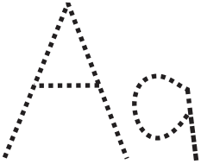
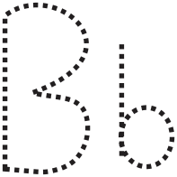

GREAT TURNING POINT INTERNATIONAL SCHOOL
3RD TERM EXAMINATION 2023/2024 ACADEMIC SESSION
SUBJECT: NUMBER WORK CLASS: PRE-NURSERY
Trace the number two (2)


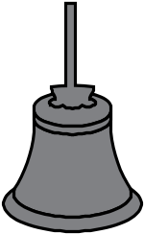


Circle two from each of the drawing you see

GREAT TURNING POINT INTERNATIONAL SCHOOL
3RD TERM EXAMINATION 2023/2024 ACADEMIC SESSION
SUBJECT: C.R.S CLASS: PRE-NURSERY
INSTRUCTION: Read the following passage and answer all questions
Topic: Prayer
Prayer means talking to God when we have problem. We kneel down to talk to God our father through prayers.
QUESTIONS
- When we have problem, we ______ (a) pray (b) cry
- Do you pray when you wake up ? (a) yes (b) no
- Do you pray when you want to go to school? (a) yes (b) no
- It is always good to kneel down, put your hands together and close our eyes when we want to pray (a) yes (b) no
- God love us and hears our prayers __________ (a) yes (b) no
- Do you love God ? _________ (a) yes (b) no
- Is Satan friendly to us? ________ (a) yes (b) no

GREAT TURNING POINT INTERNATIONAL SCHOOL
3RD TERM EXAMINATION 2023/2024 ACADEMIC SESSION
SUBJECT: ASUSU IGBO CLASS: PRE-NURSERY
INSTRUCTION: Kachie nke bu aziza na ajuju ndia
- Gini bu ekele nke ana ekele na ututu (a) ehihe oma (b) I bolachi
- Kedu ndi na ekele I bolachi na ututu? (a) ndi igbo (b) ndi ocha
- Uzo ekele ole ka ndi igbo na ekele na ubochi (a) isii (b) ato
- O na din ma I na kele ndi nne na nna na ndi toro anyi na ututu (a) mba (b) eeh

IKPOPUTA AKUKU AHU NDIA ESERESE

- (a) isi (b) ukwu

- (a) onu (b) imi


- (a) eze (b) onu

GREAT TURNING POINT INTERNATIONAL SCHOOL
3RD TERM EXAMINATION 2023/2024 ACADEMIC SESSION
SUBJECT: WRITING CLASS: PRE-NURSERY
Trace the number two (2)
Aa | Aa | Aa | Aa | Aa
Bb | Bb | Bb | Bb | Bb

GREAT TURNING POINT INTERNATIONAL SCHOOL
3RD TERM EXAMINATION 2023/2024 ACADEMIC SESSION
SUBJECT: NURSERY RHYMES CLASS: PRE-NURSERY
INSTRUCTION: Sing as written
See see see
I can see a bird
Standing on the tree
No no no
Where is my gun?
If I have a gun I will shoot it kpu
And the bird will be mine mine mine

Once I saw a little bird
Coming hop hop hop
So I said to the little bird
Will you stop stop stop
As I was going to the window to say
How do you do
But it shakes it little
And away its flew

This is the way I brush my teeth,
Brush my teeth, brush my teeth
This is the way I brush my teeth
Early in the morning

